Delta Sigma Theta Sorority, Incorporated
National Program Planning & Development Committee

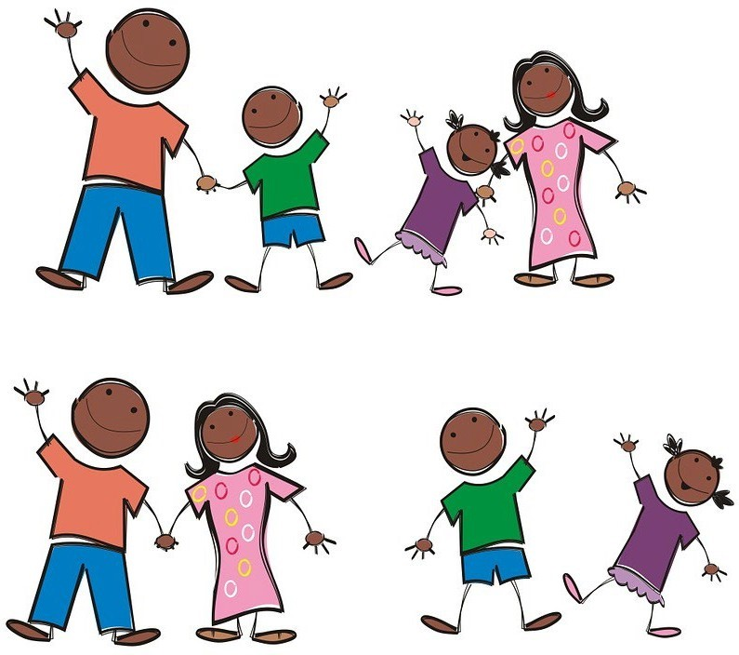

Risk Management
August 2020

WELCOME

Thank you for allowing your child to participate in one of our Delta Sigma Theta, Sorority, Inc. youth programs. All programs adhere to a set of policies and procedures designed to minimize any harm or injury to youth and any potential risks to Delta as program sponsor. The policies are set forth in the sorority’s Risk Management Manual and the Youth Initiative Volunteer Guidebook. We encourage parents and/or guardians to review the information in this Parent/Guardian Guidebook regarding our risk management policies and procedures.

Delta Sigma Theta Sorority, Inc. currently sponsors several programs designed to promote the development of young girls and boys. These include, but are not limited to, Delta GEMS, Delta Academy and EMBODI (collectively “youth initiatives”). The youth initiatives are supervised by Delta’s National Program Planning and Development Committee (PP&D), but implemented through local alumnae Chapters, sometimes with the participation of collegiate chapters.

Delta’s national youth initiative programs are:

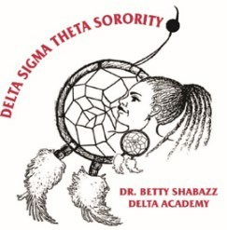

Dr. Betty Shabazz Delta Academy
This program addresses the needs of young women ages 11-14. The program focuses on social and emotional development, physiological transitioning, and exposure to global ideas and learning opportunities.

Dr. Jeanne L. Noble GEMS Institute

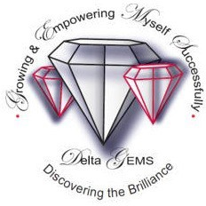
This program addresses the needs of young women ages 14-18. The program focuses on promoting high levels of academic success. Assisting young women in proper goal setting; developing compassionate, caring, community-minded women; emphasizing decision-making, and planning for the high school years and beyond.

EMBODI

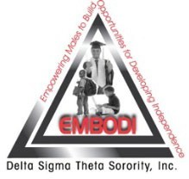
This program addresses the needs of young men ages 13-17. The program focuses on issues related to STEM education, culture, self-efficiency, leadership, physical and mental health, healthy lifestyle choices, character, ethics, relationships, college readiness, fiscal management, civic engagement, and service learning.

Delta chapters may sponsor additional youth activities. Some examples include Debutante Cotillion,
Jabberwock, Beautillion, SAT Prep and Tutoring Programs. These youth programs may vary by region, state and/or chapter but are all governed by PPD committee youth policies and guidelines.

YOUTH INITIATIVE PROGRAM CONTACTS
Note: The local chapter should insert the names and contact information for the following:

Chapter President
Kristin Allen

Chapter Risk Management Coordinator
Earline Broaden

Chapter Youth Program Coordinator
Jasmine Scott educationaldevelopment@aikendst.org

Committee Chairs
Jazmine Diggs, Delta GEMS
Nadine Diggs, Delta GEMS Co-chair
deltaacademy@aikendst.org

Ruby Stewart, EMBODI Chair
Tamika Carmichael, EMBODI Co-chair
embodi@aikendst.org

COMMUNICATION

We maintain a strong belief in the value of positive and open communication. You may receive information regarding important dates and information pertaining to our programs. Therefore, it is important that you provide us with your contact information.

PROGRAM CALENDAR

The Youth Program Coordinator shall provide parents/guardians a description of the respective youth program initiative and the expectations for the youth and the parents/guardians. For most chapters, the program calendar will be reviewed at the parent/guardian orientation.

Parental/Guardian participation, visitation and observation during youth initiative activities is encouraged. Parents/ Guardians who consistently volunteer with youth must also complete the background screening process.

NOTE: The local chapter should provide all parents/guardians with a youth initiative program calendar or the chapter can use the table below to insert the program information in this Parent/Guardian guidebook.

Activity Title | Date | Time | Location
Participant Orientation | 11/7/2020 | 11 AM | Zoom Meeting
Holiday Session | 12/5/2020 | 11 AM | Zoom Meeting
February Session | 2/6/2021 | 11 AM | Zoom Meeting
March Session | 3/6/2021 | 11 AM | Zoom Meeting
April Session | 4/3/2021 | 11 AM | Zoom Meeting

RISK MANAGEMENT OVERVIEW

DEFINITION OF RISK MANAGEMENT

Risk management is the process of assessing risk and acting in such a manner, or prescribing policies and procedures, so as to minimize loss associated with such risk. Our goal is to ensure that parents/guardians understand how risk management plays a part in our youth programs and to maintain compliance with our policies and guidelines during all youth activities.

WHY DO WE NEED RISK MANAGEMENT?

Risk Management is important because it:
- Protects the people, property, income and reputation of Delta Sigma Theta, Inc.
- Ensures the safety of all participants in our youth programs
- Proactively evaluates allocation of resources
- Allows us to focus on the enrichment of our youth participants
- Focuses on prevention

Youth programs face challenges to ensure that young people and volunteers are in a safe environment. It is important that Delta’s risk management strategies are implemented in order to ensure that a positive learning environment is achieved, and that Delta’s youth programs offer youth and volunteers an opportunity to engage in sound programs that are emotionally and physically safe.

RISK MANAGEMENT ROLES

Chapter President
- The chapter president is ultimately accountable for ensuring all national risk management policies, procedures and guidelines are followed and that all volunteers for chapter’s youth initiatives/programs have successfully completed the risk management application and screening process.

Chapter Risk Management Coordinator
- The chapter’s risk management coordinator is appointed by the chapter president and shall execute the risk management activities for the chapter and oversee the chapter’s compliance with the requirements of Delta’s risk management manual.

Youth Program Coordinator
- The youth program coordinator is responsible for coordinating and leading the youth activities in compliance with Delta’s risk management policies and the National Program Planning & Development youth guidebooks and/or guidelines. She will oversee the youth program, including the youth participants and the volunteers.

VOLUNTEERS

Delta has implemented risk management policies for all volunteers participating in our youth initiative activities. All volunteers undergo background screening and volunteer training before they will be allowed to participate as a volunteer in Delta’s youth programs. The only exception is for one-time volunteers such as speakers, vendors or presenters who only participate in a single activity.
Who is a Volunteer?
- In Delta Sigma Theta, Inc., any individual participating in Delta’s youth initiatives is defined as a volunteer. This applies to members of Delta Sigma Theta, Inc., and nonmembers (i.e. Deltas and non-Deltas).

What are the requirements for becoming a Volunteer?
- Volunteers must be 18 years of age or older
- Volunteers must complete the application process
- Volunteers must undergo and pass a criminal background check every three (3) years using Delta’s approved background check vendor
- Volunteers must complete risk management training on an annual basis
- Volunteers must sign and abide by the youth initiative code of ethics
- Volunteers must learn to recognize signs and symptoms of child abuse/neglect
- Volunteers must abide by Delta’s mandatory reporting policy
- Volunteers must meet the time requirements and job duties as directed by the local chapter

RISK MANAGEMENT POLICIES AND GUIDELINES

Delta Sigma Theta Sorority, Inc. has implemented risk management policies and guidelines for all individuals who are involved in our youth programs and they can be found in the sorority’s Risk Management Manual and the Youth Initiative Volunteer Guidebook. Following is a summary of relevant policies affecting our programs.

ACCIDENT PROCEDURES

In case of an accident, we will first attempt to notify the parents/guardians, emergency contacts, and then the child’s physician. If it is impossible to reach any of the above, we will transport according to the emergency form listing, as necessary. Extreme emergencies may dictate other procedures deemed in the child’s best interests. Whenever a child is injured, regardless of the severity of the injury, an incident form and applicable witness statements are completed and maintained.

ALLERGIES, ILLNESSES, SPECIAL NEEDS

Information relating to allergies, illnesses, and special needs must be communicated to the chapter.

We are happy to work with you to ensure your child is safe in our care. If it is a life-threatening allergy, please provide all details and emergency procedures to follow. All medications to be dispensed must be provided to the chapter. Additionally, all necessary medical forms must be provided to the chapter.

MEDICATIONS

Medication is administered only when accompanied by a properly completed medication form including the child’s name, name of medication, time and amount of dosage and parent’s signature. We provide the necessary forms for your use and will be provided by the chapter. Medication must be in its original container. Prescription medication must have a label stating the name and contact information of the pharmacy, physician, child’s name, name of the medication and medication directions. No medicine can be given after the expiration date on the label. Over the counter medications such as Tylenol, Motrin, etc., are not administered by the chapter without the necessary forms on file with the chapter.

BEHAVIOR

All youth are expected to behave in a manner that is acceptable to our standards and must sign the Youth Code of Conduct. If a youth behaves in an unacceptable manner, the youth is redirected, shadowed, or removed from the activity for a brief period. Unacceptable behavior is defined as that which is to the group as a whole during structure and activity time, behavior which may be harmful, or behavior compromising the safety of the group or individuals. Physically or verbally hurting (bullying) other youth and/or volunteers is unacceptable. In the event that a youth continues to be disruptive, harms others, or put themselves at risk, the chapter has the right to dismiss youth from the program. Parents will be notified of such behaviors as they occur so we can work cooperatively on strategies and solutions.

DROP-OFF AND PICK-UP PROCEDURES

All youth must be picked up and signed out from the activity or program. In addition, all youth must be signed out by a parent, legal guardian or someone who is on the authorized pick-up list. Any additions to the pick-up list must be authorized by the parent/guardian in writing. Those unfamiliar to us will be asked to show a photo ID.

PARENTAL/GUARDIAN PARTICIPATION REQUIREMENTS

Parents or guardians who participate, visit, and/or observe youth initiative activities that require their interaction with other youth may be requested to complete Delta’s criminal background check screening process.

TRANSPORTATION

Parents are responsible for transporting their child to program activities and events. However, if the parent allows another to transport their child, the parent must execute, as applicable: A Waiver and Permission to Transport Youth and/or A Parent Waiver and Permission for Teenage Driver to Transport Youth. These forms will be provided by the chapter.

SUPERVISION

We do not allow one-to-one, isolated contact between adults and youth, e.g. tutoring, training classes, etc. Family members and others who are allowed or permitted to attend a youth initiative activity will be provided with guidelines on acceptable conduct.

PHOTOGRAPHY

Chapters are required to have the executed Photograph, Media and Video Authorization Release form prior to photographing or videotaping youth and prior to using any photographs and/or videos for chapter-related activities.

When a photograph or video of any youth is used in any printed medium, online or in materials that will be printed online, no identifying information about the youth shall be included (e.g., the youth’s name, school, church and/or city of residence).

It is a violation of Delta’s risk management policy for volunteers to post photographs or videos of youth participants on their personal social media.

OUT OF PROGRAM ACTIVITIES AND CONTACT WITH PROGRAM PARTICIPANTS

There shall be no unsanctioned contact between volunteers and youth participants outside of Delta’s youth initiative activities without the express written permission of the parent/guardian, or unless the parent/guardian is present.

FUNDRAISING

Youth participants in our national youth enrichment programs, e.g. Delta Academy, Delta GEMS and EMBODI, are not allowed to participate in fundraising activities to support their programs or other chapter programs.

Chapters may sponsor Jabberwocks, Cotillions or similar events as fundraisers. For these type of youth activities, youth participants are allowed to participate in fundraising activities.

Further, in order to protect the youth participating in Delta’s fundraising events, we strongly advise that youths participating in our programs should not be allowed to solicit funds without being accompanied by you or a supervising adult.

Parents of participants in programs where fundraising is permitted can use crowd funding accounts to raise funds in support of their child’s participation, but the crowd funding site must be reviewed by the Chapter President or a designee prior to being launched.

As part of any Jabberwock, Cotillion or other fundraising event involving youth, parents are required to participate in a Background Check Screening Process using Delta’s background check vendor.

ALCOHOL USE POLICY

No member or their guests shall consume alcoholic beverages while in the presence of minors who are attending or participating in any Delta youth initiative program, i.e. Delta Academy, Delta GEMS, EMBODI or any other Delta-sponsored youth program. This policy also applies to volunteers and parents participating in any Delta youth initiative program.

TRANSGENDER MEMBER POLICY

- Youth Initiatives and Gender-Specific Scholarships

Delta Sigma Theta Sorority, Inc., will consider for youth initiatives and gender-specific scholarships any female or male, any individual who self-identifies as female or male, regardless of her/his assigned sex at birth,; or her/his expression, or the perceived expression of her/his gender for female or male Delta Sigma Theta’s youth initiatives and female or male gender-specific scholarships.

- Youth Initiative Volunteers

Volunteers for youth initiatives who are not members of Delta Sigma Theta Sorority, Inc., should be cisgender individuals only (defined as relating to, or being a person, whose gender identity corresponds with the sex the person had or was identified having at birth).

Virtual Meetings & Publicity

Delta Sigma Theta Sorority, Inc. has guidelines for chapters to use virtual platforms in conducting youth initiative activities. Chapters must adhere to mandatory requirements for printing or publishing personal identification information regarding any youth.

PARENT/GUARDIAN FORMS

We require parents and/or guardians to complete certain forms for their youth to participate in our youth programs. The forms have been approved by Delta Sigma Theta Sorority, Inc., for use by all chapters. The forms that should be provided to you are listed below and must be returned to the chapter before the youth is allowed to participate in any youth program.

- Form B1: Parental/Guardian Affirmation

- Form B2: Photograph, Media and Video Authorization Form

• | Form B3: | Youth Code of Conduct
• | Form B4: | Youth Pick-up Authorization
• | Form B5(a): | Waiver and Permission to Transport Youth
• | Form B5(b): | Parent Waiver and Permission for Teenage Driver to Transport Youth
• | Form B6: | Off-site Permission
• | Form B7: | Medical Information and Treatment Authorization Packet
• | Form B8: | Medication Authorization
• | Form C1: | Confidentiality Policy
• | Form C2: | Child Abuse Reporting Numbers
• | Form C3: | Youth Sign-In/Sign-Out Policy
• | Form C4: | Internet Use Policy

In addition, parents /guardians must complete or be provided the following forms/notices in Delta’s Virtual Meetings & Publicity Guide:

- Youth Initiative Virtual Meeting/Event Participation Agreement

- Youth Initiative Virtual Meeting & Publicity Code of Conduct

- Media & Publication Release form

- Media Release
- Print and Online Publication Parental Notice

ALL PARENT AND YOUTH FORMS ARE RETAINED AS PART OF THE CHAPTER’S RECORDS.

